# Buy & Sell Web App

# Level-6 Final Project

Table of Contents

**Project Proposal 3**

**Goals and Objectives 3**

**Project Scope 3**

**Project Specifications 3**

**Target Audience 3**

**Project Deliverables 4**

**Resource Requirements 4**

**Project Tasks and Milestones 4**

**Project Assumptions 5**

**Project Report 5**

**Detail Design 6**

**Home Page 6**

**Register** **Page 6**

**Login Page 7**

**All Sub Type Admin View 7**

**My Products Page View 8**

**All Products Page** **View 8**

**Sub Type Wise Product** **View 9**

**Product Details** **with Request View 9**

**Project Testing 10**

**User Manual 10**

**Summary 10**

**System Configuration 10**

**User Access Levels 10**

# 

# Project Proposal

## Goals and Objectives

The project's main goal is to create a web application called "Buy & Sell" that works online. Occasionally, we make purchases that we later come to regret. So, Buy & Sell is a web portal where buyers can upload product details and sellers can request to purchase them. The web application's primary goal is to accomplish this. There are two types of users in this application: admin and registered visitor. Admins have different capabilities than registered users. Admins can add, edit, delete, and check the details of product types and subtypes. A registered user can add products and manage them according to their preferences, as well as request the purchase of other users' products.

# Project Scope

The goal is to create an online application called "Buy & Sell," which will allow users to sell and buy products. The project will take 20 working days, or 4 weeks, to complete.

# Project Specifications

# • Login/logout for administrators

# • You can add, edit, delete, and check the details of Product Types and their subtypes.

# • The administrator has the ability to add new administrators.

# • Registered users have the ability to login and logout.

# • You can register as a new user.

# • Registered users have the ability to add new products for sale to the website.

# • Registered users have the ability to send a purchase request to their seller.Target Audience

The people who want to sell and buy products online are the target audience for this project. The age ranges from 20 to 75 years old.

# Project Deliverables

The deliverables of the project are:

|  |  |
| --- | --- |
| Deliverable | Description |
| Final Report | This will be the final report of the project. |
| Coding | The executable code of the project will go under this. |
| Documentation | This portrays the documentation of the project. |
| Testing | All the test details will be covered in this part. |

# Resource Requirements

* Windows-8 or 10 Operating System.
* Microsoft word for documentation.
* Asp.net MVC-5+ Framework
* 64-bit Processor and 4 GB or more RAM

# Identity framework- Project Assumptions

* The following are the assumptions that were made during the project's implementation:
* • By default, one administrator and two registered users will be created.
* • The application will be open source and free.

# Project Report

#### Functional and Non-Functional

|  |  |
| --- | --- |
| Users | Functional |
| Admin | * Login/logout * Register new admins * Admin can add, edit, delete, check details for product type and their sub types. |
| Buyer / Seller | * Can view details of all products available at database * Registered user capable to add product to sell * Registered user capable to purchase the product by sending request * New customers can register for free. * Login using valid credentials |
|  | Non- Functional |
|  | * High speed * Fast Loading time * High performance and security * All browsers compatibility. |

# Detail Design

### Home Page

The application's main landing page. Home, All Category, Sell Product, Register, and Login are the options on the navigation bar. The most recent product to sell list is also displayed on this home page.

* Graphical user interface, application

  Description automatically generated

# Register Page

With the help of this page, new visitor can register online

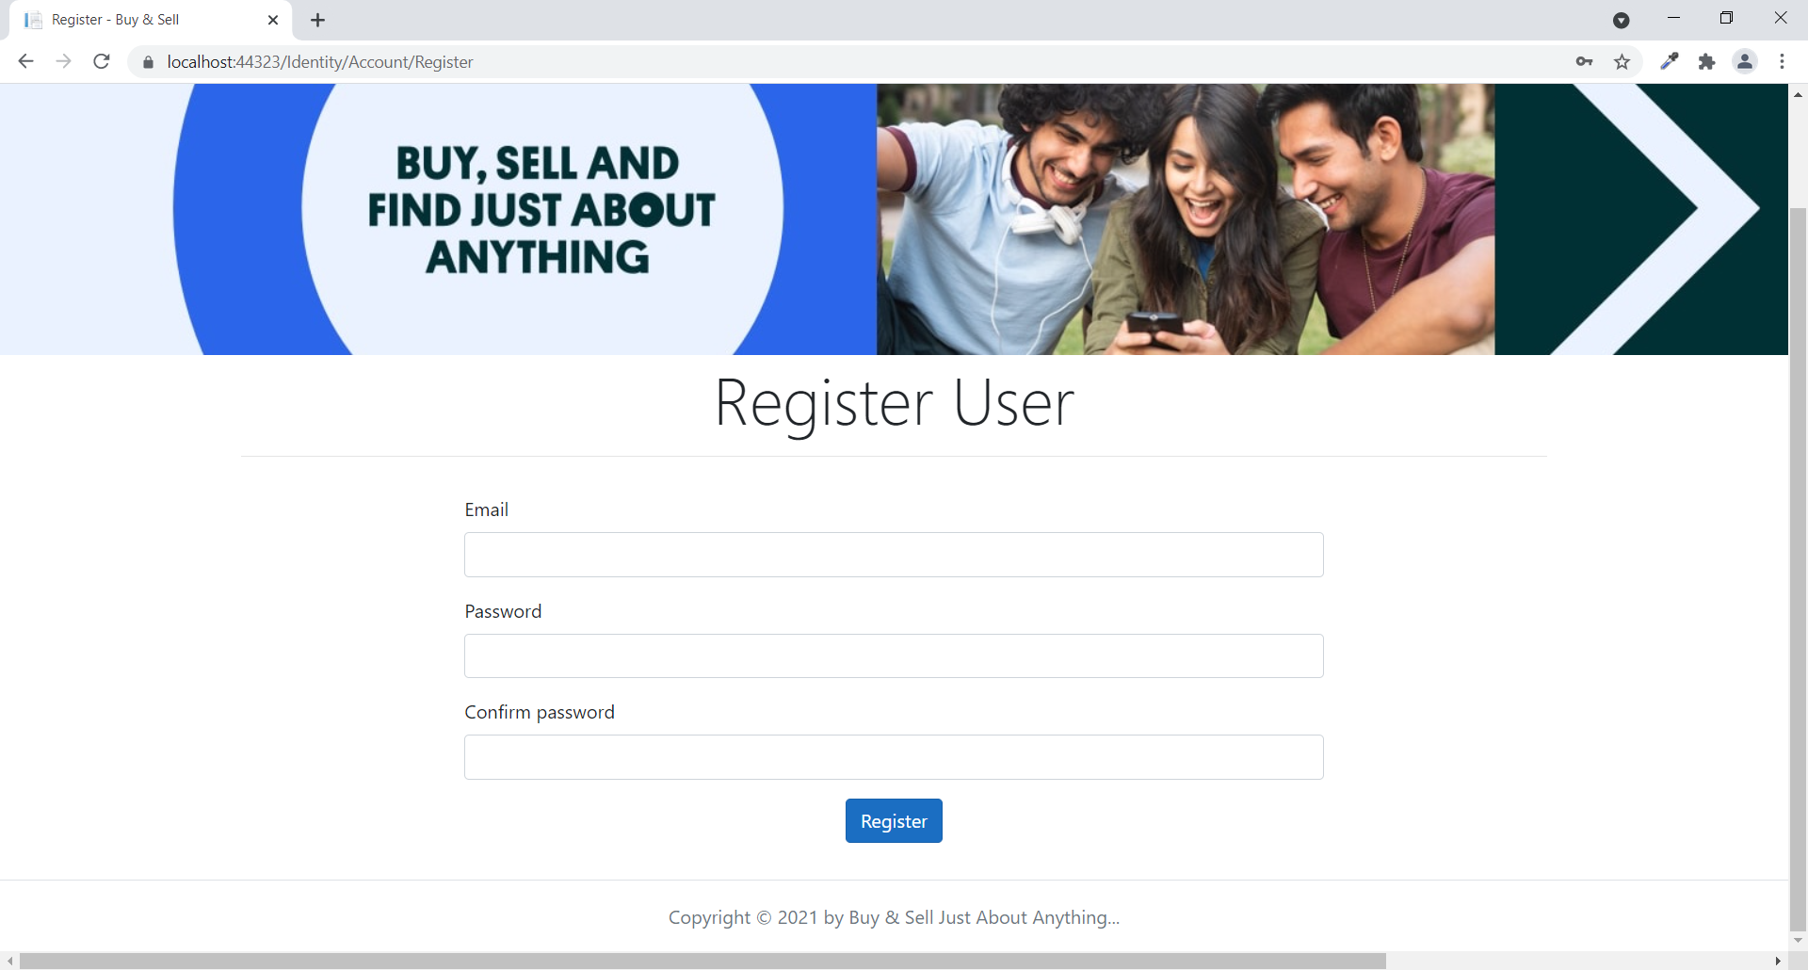

# Login Page

With the help of this page, visitor can login to page and access unrestricted page.

# All Sub Type Admin View

This page provides a way to Admin View of All Sub Type Operations

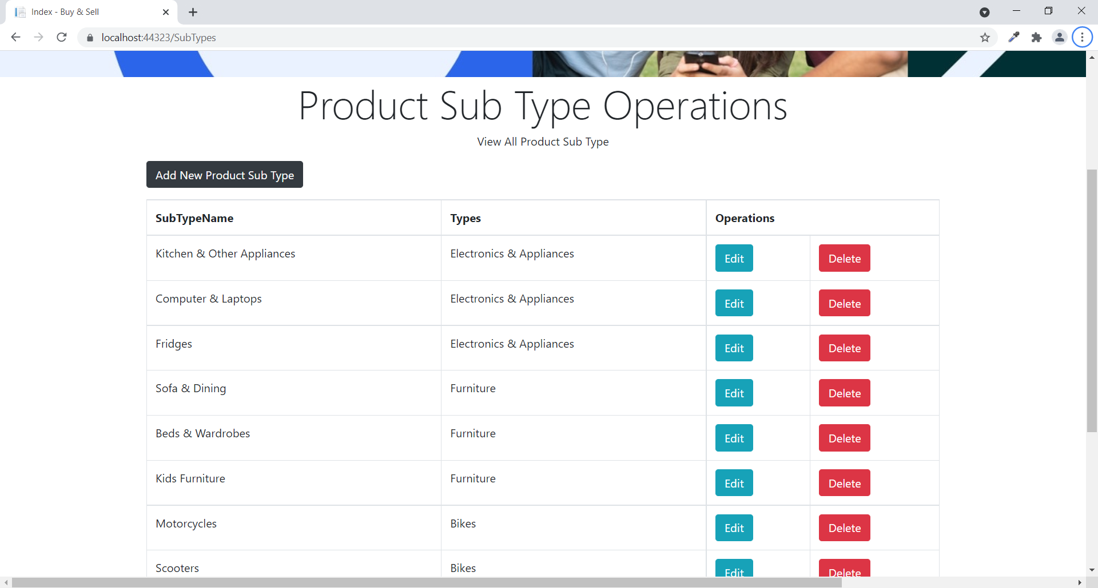

### 

# My Products Page View

With the help of this page registered user can view all product which are submit by himself/herself to sell.

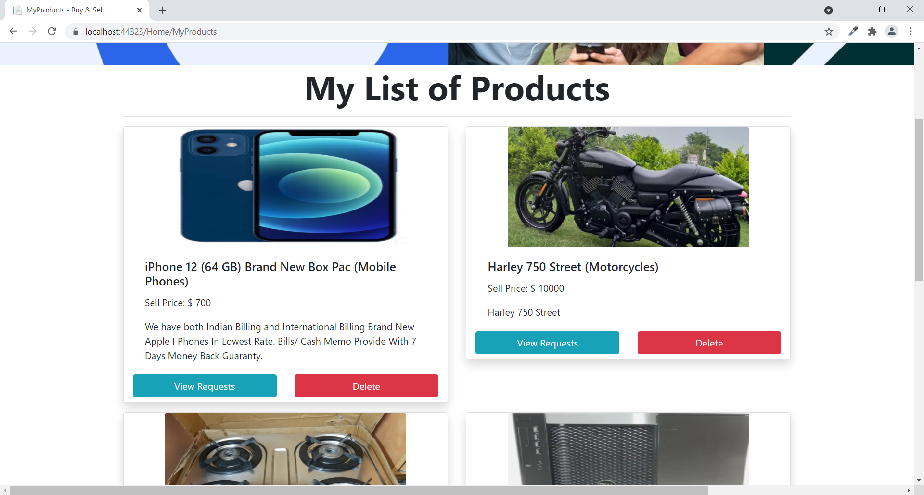

# All Products Page View

With the help of this page Visitor/Registered user can view all product information with Details link.

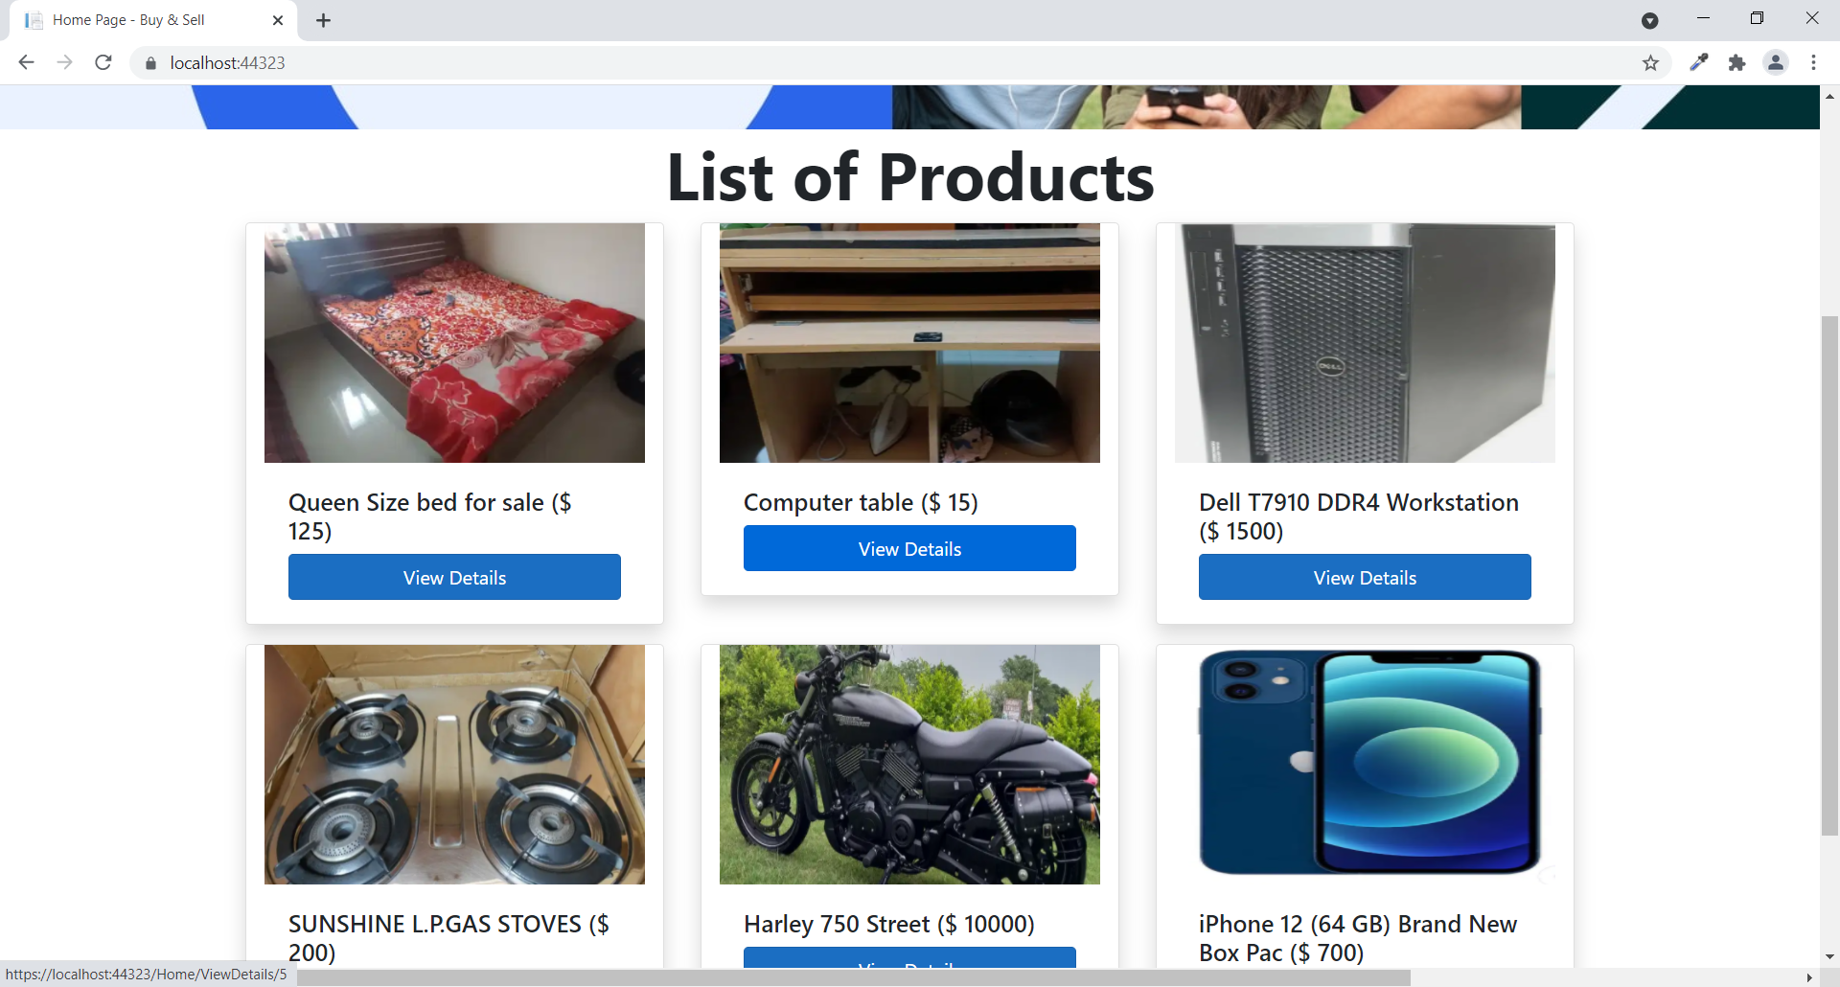

# Sub Type Wise Product View

With the help of this page visitor can view all product of a sub type.

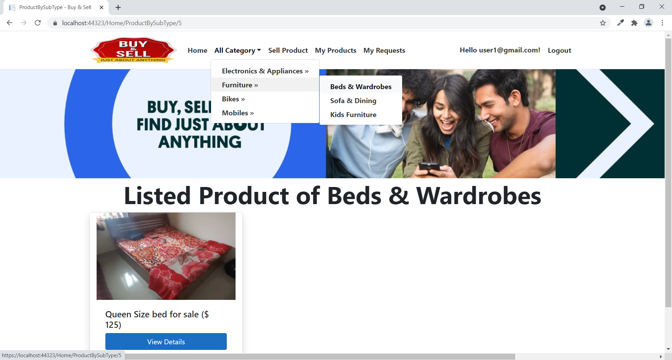

# Product Details with Request View

This page shows the Product Details with all incoming Requests.

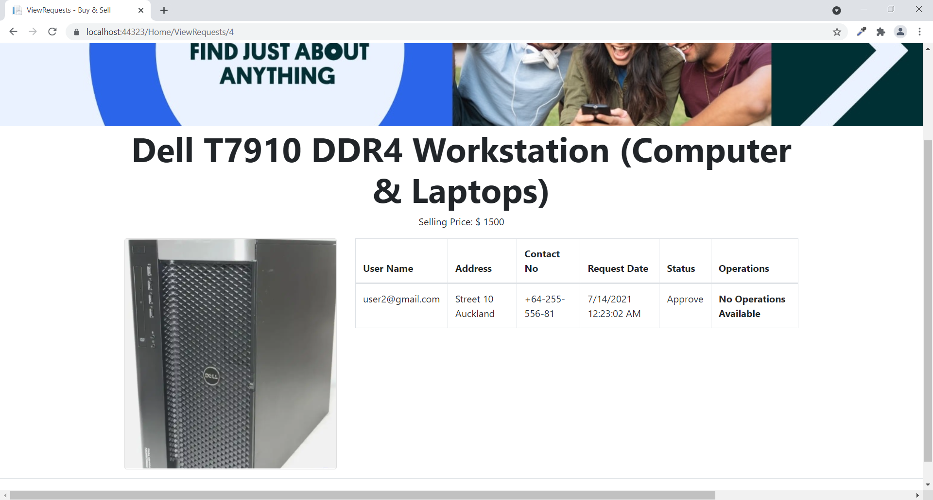

# Project Testing

The testing file for usability testing is attached as [usability test.xlsx](usability%20test.xlsx)

# User Manual

The main goal of the Buy & Sell application is to provide a portal where sellers can submit product details and buyers can create purchase requests. There are two types of users in this application: admin and registered user or visitor. Admins have different capabilities than registered users. Admin can add, edit, delete, and check product type and sub type information.

# Summary

### System Configuration

This app will be useful to for distributing mobile information in presentable format.

### User Access Levels

Only registered users can access the features of this application.

* **Admin:** Admin has full access of the app can register new admins.
* **Registered Visitor:** New visitor can register and existing can login using their own credentials. They have limited access.